Complete the following Frayer model using the term: two term ratio. Be sure to use your text to help you complete each section.

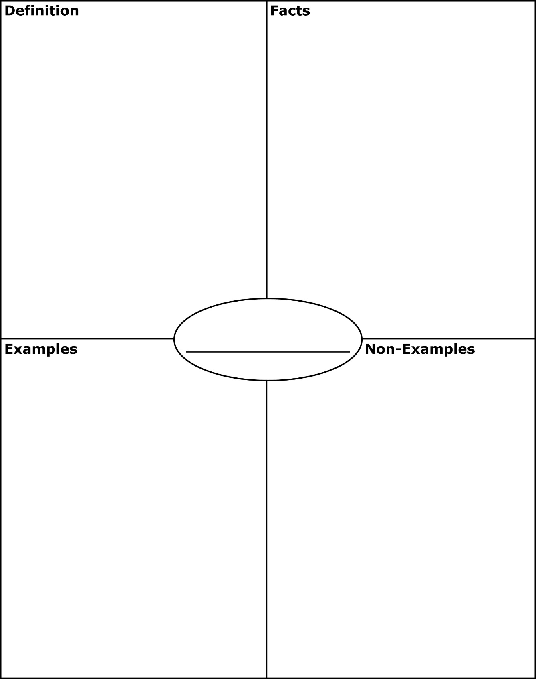



Complete the following Frayer model using the term: rate. Be sure to use your text to help you complete each section.





Complete the following Frayer model using the term: proportion. Be sure to use your text to help you complete each section.





Create your own word problem which uses proportions and then show how you would solve it.