Math 9 Journal Entries
Learning Guide 6
Expectation 1: Model, record and explain the operations of multiplication and division of polynomials.
Part A) Multiplying Monomials:
You can represent the multiplication of monomials using a model. For example, the following model shows (2x)(-2x).
To get the answer using your model, count how many negative x² tiles you have.
There are _______ negative x² tiles in the model below.
(2x)(-2x) = ______x²

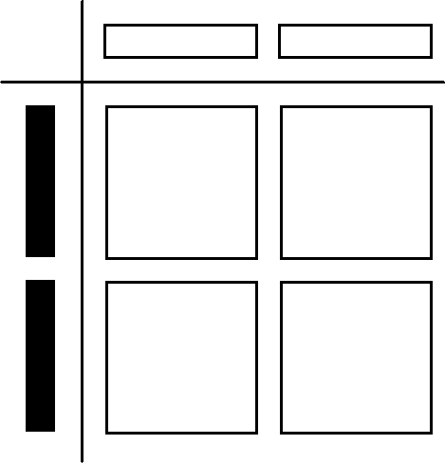

To multiply monomials algebraically, you can multiply the numerical coefficients, and use the exponent rules to multiply the variables.
Please note: Remember your integer rules for Multiplying ;
When multiplying two integers with the same sign, the answer is __________________.
Example- (-2)(-3) = +6
When multiplying two integers with different signs, the answer is _________________.
Example- (-7)(4) = -28
Complete the following multiplication questions:
- (5x)(6x) =
- (-3y)(4y) =
- (-w)(-8w) =

Part B) Dividing Monomials:
Read the Key Ideas section on page 259 and then complete the following:
You can represent the division of monomials using a model. For example, to build a model which shows -6x² ÷ 3x, arrange the 6 negative x²-tiles into a rectangle so that one of the sides is 3 x-tiles long. (see the diagram below)

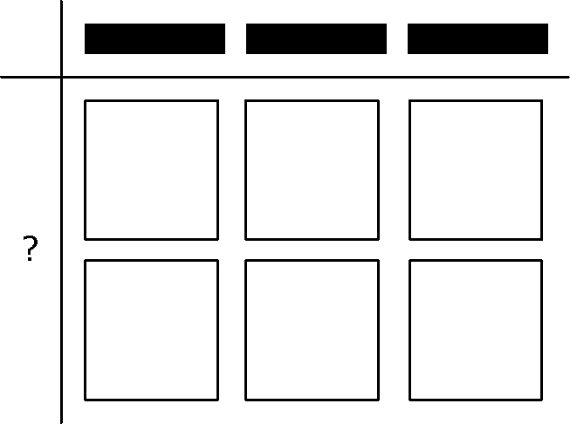

Now, to find the answer using the model, we have to determine the expression for the unknown side length (ie. The ? in the diagram above). The unknown side length of the rectangle is made up of 2 negative x-tiles.
So, the answer to the question = - 2x

To divide monomials algebraically, you can divide the numerical coefficients, and use the exponent rules to divide the variables (ie; subtract exponents).
Divide the following using the algebraic method above:
a) = b) -0.8xy ÷ 0.2x =

Part C) Distributive Property:
Read the Literacy Link on page 267 and use it to help you describe the distributive property: _________________________________________________________________________________________________________________________________________________________________________________________________________________________________________.
Use the last part of the Key Ideas on page 268 to help you complete the following questions using the distributive property:
a) (-1.2x)(3x – 7) b) (-4y + 5)(2y)

