Workplace Mathematics 11

Unit 5 Project: Learning Guides 12, 13, 14

STATISTICS & GRAPHS

MARK:

Student: _________________

T.A.: _____

Teacher: __________________

COMPLETING THIS UNIT PROJECT /25 marks

ACTIVITIES:

Complete the following activities:

PART I:
◻ Broken Line and Bar Graph
- Use the data provided to create the graphs
- Answer the questions
(Presentation is important)

PART II:
◻ Circle Graph
- Use the data provided to determine the fraction, percent and angle
- Create the graph using a protractor
(Presentation is important)

PART III:
◻ Histogram & questions
- Use the data provided to create the graph
- Answer the questions
(Presentation is important)

PART I - Broken Line and Bar Graph

REMEMBER: GRAPHING IS ALL ABOUT PRESENTATION. Messy work will be returned or given a reflective mark.

Use the data to the right to create two graphs:
Month | Amount of Rain  (mm)
January | 100 mm
February | 70 mm
March | 80 mm
April | 70 mm
May | 50 mm
June | 20 mm
    - a broken-line graph
and
    - a bar graph.

For each graph below: ◻ include the “scale” (i.e. the months and increments for mm) 1 mark
◻ label the axis 1 mark
◻ include a title 1 mark

Broken-Line graph |  |  |  |  |  |  |  |  |  |  |  |  |  |  |  |  |  | Bar graph

Questions: 1 mark each

- Which month has the most precipitation?
ANSWER:
- How much rain falls in that month?
ANSWER:
- Which months have the same amount of rainfall?
ANSWER:
- How much more rain falls in January than falls in February?
ANSWER:

/10

PART II - Circle Graph

REMEMBER: GRAPHING IS ALL ABOUT PRESENTATION. Messy work will be returned or given a reflective mark.

For each student on the table below fill in: 1 mark per student (5 marks total)
◻ the fraction of the total ◻ the percent of the total
◻ the angle to use when drawing out your pie chart

Student | Hours Worked | Fraction of total | Percent of total | Angle  (Used on the pie graph)
Nathan | 5
Sara | 8
Austin | 12
Kaitlyn | 5
Ryan | 10
Total | 40 |  | Total | 360º

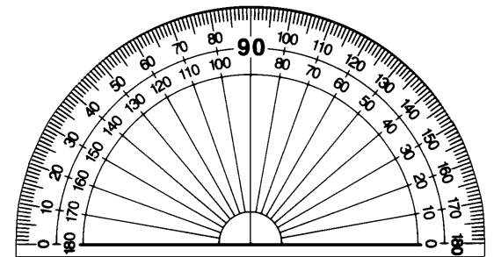
For the next part of the
assignment
you will need a protractor →

Use the angles determined above and a protractor to create the pie chart below. Make sure that you label the students on the chart or use a “colour legend”. 4 marks

•

/9
PART III - Histogram

REMEMBER: GRAPHING IS ALL ABOUT PRESENTATION. Messy work will be returned or given a reflective mark.

Use the data below to create a histogram.

Television viewing
Time spent watching TV (hours) | 0 ≤ h < 5 | 5 ≤ h < 10 | 10 ≤ h < 15 | 15 ≤ h < 20 | 20 ≤ h < 25 | 25 ≤ h < 30 | h ≥ 30
# of people | 25 | 90 | 70 | 91 | 35 | 10 | 6

On your histogram below: ◻ include the “scale” (i.e. the Time and Number of People) 1 mark
◻ label the axis 1 mark
◻ include a title 1 mark

Histogram

Questions: 1 mark each

- How many people watch between 10 and 15 hours of television each week?
ANSWER:
- How many people watch less than 15 hours each week?
ANSWER:
- How many people watch 15 or more hours of television during the week?
ANSWER:

/ 6

