**Math 8 Journal Entries**

**Learning Guide 5**

**Expectation 1: Label and draw views of 3-D objects**

For the following object, draw the top, front and side views.



**Top View:**_______________________________________

**Front View:**__________________________________________________________

**Side View:**__________________________________________________________

**Expectation 2: Draw and build nets for 3-D objects.**

Draw a net on the grid provided for the following object:





**Expectation #3: Calculate the Surface Area of a Prism.**

Calculate the total surface area of the following object:



Use a ruler to measure the dimensions of the sides needed to calculate the surface area for the following figure. Then use your measurements to calculate the surface area.

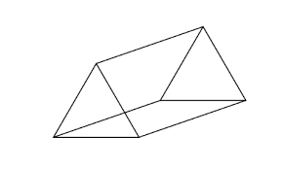

**Expectation #4: Calculate the surface area of a cylinder.**

Calculate the total surface area of the following object:

