**Math 9 Journal Entries**

**Learning Guide’s 4&5**

**Expectation 1: Demonstrate an Understanding of Polynomials**

Part A) Vocabulary: Use the purple boxes on pages 174 to 176 to help you define and give an example of the following terms.

Algebra - __________________________________________________________________

Term - _____________________________________________________________________

*Example of a Term*- ___________________________________________________________

Polynomial - _________________________________________________________________

*Example of a Polynomial -* _____________________________________________________

Degree of a Term- _____________________________________________________________

*Example of Degree of a Term -* _____________________­­______________________________

Degree of a Polynomial- _________________________________________________________

*Example of Degree of a Polynomial*- ________________________________________________

Use the Literacy Link on page 176 to name the three types of polynomials, define them and give an example of each.

1. ____________________________________________________________________ ____________________________________________________________________
2. __________________________________________________________________________________________________________________________________________
3. __________________________________________________________________________________________________________________________________________

**Expectation 2: Model, record and explain addition and subtraction of polynomials.**

**\*\*\*Sign out an algebra tiles kit from the science kiosk to use in the math GH**

1. Identify each of the following tiles from the kit

|  |  |
| --- | --- |
| = positive 1-tile (red)  = positive *x*-tile (green)  = positive *x*2  (green) | = negative 1-tile (white)  = negative *x*-tile (white)  = negative *x*2  (white) |

B) **Write the expression represented by each set of algebra tiles.**

a) ____________________



b) ____________________



c) ____________________



d) ____________________



**\*\*\* Please remember to return your algebra tiles kit to the science kiosk.**

**Expectation 2: Model, record and explain addition and subtraction of polynomials.**

Part C) Use the purple box on page 184 to help you define and give an example of the following:

Like Terms: ­­­­­­­­­­­­__________________________________________________________________

*Example of Like Terms*: _________________________________________________________

Part D) Determining Opposite Polynomials

Opposite polynomials add to zero and to find an opposite polynomial using algebra tiles, you just turn each tile over (ie FLIP IT).

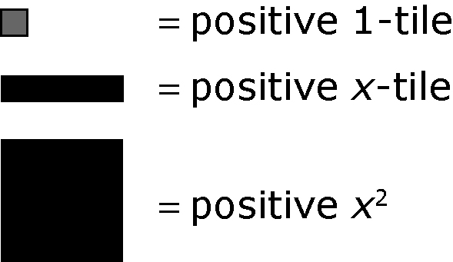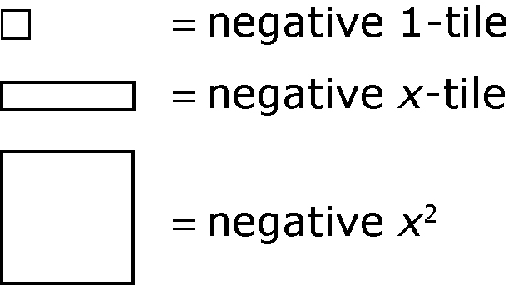

Determine the opposite of the expression represented by each diagram.

**a) b)**

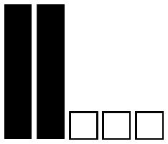

Expression: 2x – 3 Expression: -x2 – 3

Draw the diagram of the opposite polynomial (ie flip the algebra tiles and draw the result

1. b)

Expression: ________________ Expression: __________________

Part E) Subtracting Polynomials

To subtract a polynomial, add its opposite.

Example:

(3x – 5) – (2x - 3)

Step 1: Use algebra tiles to model each polynomial in brackets. Draw the tiles below:

Step 2: Take the opposite of the second polynomial by flipping the tiles that represent that bracket (ie: flip the two x-tiles so that they are both white and flip the three unit tiles so that they are all red). Draw the new tiles below:

In symbols, you have just done:

(3x – 5) – (2x – 3) = (3x – 5) + (-2x + 3)

Step 3: Add all of the tiles, removing zero pairs if necessary. The remaining tiles are your answer. Draw your answer below.

You should have one green x-tile left and two white unit tiles left. This means that your answer is 1x – 2